PROJECT PROPOSAL

Design and Development of a Cloud-Based Student Management System as a Foundation for a Future Intranet Platform at Lutheran Church College, Banz, Jiwaka Province

Prepared By:

Mond MARE
Student ID: 180170
Bachelor of Information Systems
Department of Information Systems
Faculty of Business & Informatics
Divine Word University

2026

Supervisor(s):

Mr. M. Cletus | Mr. C. J. Kupini
Department of Information Systems | Faculty of Business & Informatics
Divine Word University

Table of Contents
Table of Contents 2
1. Introduction 4
2. Project Context 4
2.1 Background 4
2.2 Problem Statement 5
Student Information Management 5
Administrative Inefficiencies 6
Communication Challenges 6
Information Accessibility 6
Reporting Difficulties 6
Data Security and Integrity Risks 6
Poor Data Integration 7
2.3 Purpose and Significance 7
Purpose 7
Significance 7
3. Literature Review 8
Student Management Systems in Educational Institutions 8
Academic Information Systems and GPA Management 8
Cloud Computing in Education 8
Microsoft Azure for Educational Applications 9
Intranet Systems in Higher Education 9
Role-Based Access Control in Educational Systems 9
4. Methodology 10
4.1 Project Framework and System Development Approach 10
5. Project Plan 11
5.1 Project Scope 11
System Modules 11
Resource Requirements 13
Budget Estimate 14
5.2 Tentative Schedule 14
5.3 Key Deliverables 15
6. Proposed Solution 16
6.1 System Architecture 16
6.1.1 Description 16
6.1.2 Network Design 18
6.1.3 Database Design 18
6.2 Process Design 22
Process 1: Student Admission and Enrolment 22
Process 2: Course Registration 22
Process 3: Assessment, Marks Entry, and Results Publication 22
Process 4: Attendance Recording and Monitoring 23
Process 5: Staff-Student Instant Messaging (Communication Portal) 23
Process 6: Accommodation Allocation and Welfare Management 23
6.3 Future System Expansion 24
7. Conclusion 24
8. Glossary 26
9. References 28

1. Introduction
This proposal outlines the design and development of a Cloud-Based Student Management System (SMS) for Lutheran Church College (LCC) in Banz, Jiwaka Province, Papua New Guinea. The goal of this project is to provide an integrated, secure, and scalable digital platform to manage all student, academic, and administrative information within the college.
As Phase One of a larger digital transformation initiative, this system uses a modular design built on Microsoft Azure Cloud infrastructure. It is designed to host the college's daily operations securely under its registered domain (lccb.ac.pg) while serving as the foundation for a future, campus-wide Intranet platform.

2. Project Context

2.1 Background

Institutional Context
Lutheran Church College (LCC) is a faith-based college in Banz, Jiwaka Province, run by the Evangelical Lutheran Church of Papua New Guinea (ELC-PNG). The college offers academic programs across three faculties and multiple departments. It serves a diverse student body from Jiwaka, Western Highlands, and nearby provinces, making it a key provider of higher education and professional training in the Highlands region.

The Current Manual Setup
Right now, LCC manages all academic and office work manually. Student records—such as personal details, enrollment history, class lists, attendance, and grades—are kept in handwritten paper registers, physical filing cabinets, and basic spreadsheets.
Because there is no central database or shared digital system, different departments cannot look up student information in real time. Instead, each faculty and office keeps its own separate records, creating isolated blocks of information that make campus coordination difficult.

Communication and Learning Challenges
Communication across the college is also disconnected. Staff and students rely on physical notice boards, printed hand-outs, and word-of-mouth to share class schedules, deadline changes, and school announcements. There is no digital platform for staff and students to communicate outside of the classroom. Furthermore, learning materials and school documents are not stored in a central online space, making it slow and difficult for students to access academic resources reliably.

Student Housing and Welfare
The college provides on-campus housing for students traveling from outside Banz. However, managing and assigning hostel rooms is done entirely on paper with no way to track room availability. Student welfare records—including counseling, academic support, and medical referrals—are handled the same way. Because these files are not connected to a student's academic profile, it is difficult for staff to provide complete, well-rounded support.

The Need for Change
As LCC continues to grow, relying on these manual systems is no longer sustainable. Moving to a centralized, secure digital system is no longer just a convenience—it is necessary for the college to meet modern standards of school administration, governance, and student services. The proposed Student Management System directly solves these challenges.
Figure 1 below illustrates the current manual operational environment at Lutheran Church College.

Current State — Manual Operations at Lutheran Church College
Student enrols (paper form) | → | Records filed manually | → | Marks entered in register | → | Results on notice board | → | No digital communication | → | No reporting capability

Figure 1: Current Manual Operational Process at Lutheran Church College

2.2 Problem Statement
The lack of an integrated information system at Lutheran Church College (LCC) has created major operational challenges. These issues harm administrative efficiency, data accuracy, campus communication, and overall school governance. Based on the project's System Vision Document, the core problems are broken down below:

Student Information Management
All student data—including enrollment, grades, GPA calculations, and academic history—is handled manually. Staff use paper registers and basic spreadsheets to record marks, creating a high risk of errors, duplicated data, and unauthorized changes. There is no digital audit trail to track who edits records, no automated system to calculate GPAs, and no way to instantly generate transcripts. Furthermore, physical files are vulnerable to damage or loss, and there is no backup system in place.

Administrative Inefficiencies
Core tasks like processing enrollments, registering for courses, creating timetables, and updating records require repetitive manual work. Staff spend hours moving between different offices to collect data, process paper forms, and build reports by hand. This setup slows down operations, increases the chance of human error, and takes staff attention away from supporting students.

Communication Challenges
LCC currently has no central digital communication platform. Important announcements—such as exam schedules, timetable changes, and deadlines—are posted on physical notice boards or shared by word-of-mouth. These methods are unreliable, cannot be searched or archived, and fail to reach students who are off-campus. There is also no way for staff and students to message each other directly outside of face-to-face meetings.

Information Accessibility
It is difficult for both staff and students to access academic information quickly. Finding a student's past grades often requires digging through physical files in multiple offices. Lecturers cannot instantly view class lists or student profiles from their own desks, and students have no self-service portal to check their own grades, attendance, or enrollment status without visiting an office in person.

Reporting Difficulties
Creating standard school reports—such as enrollment summaries by faculty, student performance trends, or hostel occupancy rates—requires gathering and blending data from multiple manual sources. This process is incredibly slow, prone to mistakes, and hard to replicate consistently from term to term.

Data Security and Integrity Risks
Paper files are highly vulnerable to fire, water damage, pests, theft, and natural wear and tear. Because there are no strict access controls or change logs, the college cannot properly monitor who views or edits sensitive files. Critical documents like exam records and official letters risk being permanently lost with no way to recover them.

Poor Data Integration
Information regarding students, classes, staff, housing, and welfare services lives in separate, disconnected systems. A student's academic record is not linked to their campus housing file, nor is their attendance linked to their welfare history. This fragmentation makes it very difficult for management to get a complete view of a student's situation or make data-driven decisions for the college.

2.3 Purpose and Significance

Purpose
The main goal of this project is to build a secure, cloud-hosted Student Management System that brings all of LCC’s academic and office information into one central place. It will give students, lecturers, administrators, and management the specific digital access they need to do their jobs effectively. By replacing manual workflows with automated digital steps, the system will completely remove the risks and inefficiencies of the current paper-based setup.

Significance
The value of this project covers four main areas:
- For the College (Institutional Level): The system will transform LCC from a disconnected, paper-heavy environment into a highly efficient digital network. Management will get real-time data and reports to make better decisions and plans. Office staff will save time by no longer doing repetitive paperwork, allowing them to focus on supporting the school and its students.
- For the Students (Student Level): Students will be able to easily check their grades, register for classes, and message staff through a personal online dashboard. The housing and welfare modules will also ensure that student support services are well-organized, making campus life much better.
- For the Country (National Level): This project supports Papua New Guinea’s digital goals outlined in the National ICT Policy Framework 2022–2027, which urges provincial schools to adopt digital tools. Using Microsoft Azure Cloud fits the government’s "cloud-first" approach, keeping hardware costs low while keeping data safe and reliable.
- For Me Personally (Personal Level): This project is the final practical requirement for my Bachelor of Information Systems at Divine Word University. It allows me to use the skills I learned over four years—such as database management, web design, cloud computing, and project management—to solve a real problem in PNG. Having seen the struggles provincial schools face, I am highly motivated to provide a practical, lasting tech solution that truly helps the students and staff at LCC.

3. Literature Review

Student Management Systems in Educational Institutions
Student Management Systems (SMS)—also called Student Information Systems (SIS)—are all-in-one software platforms. They bring student records, grades, attendance, and communication tools into one digital place (Laudon & Laudon, 2022). Schools use them to cut down on office costs, improve daily operations, and help management make better decisions based on real data (Stair & Reynolds, 2023). Research shows that schools using an SMS benefit from centralized data, easier report building, better staff-student communication, less paperwork, and a better overall experience for students (Turban et al., 2021).
In developing regions like the Pacific, research highlights that systems must match the school’s actual size and budget. Large, complex corporate systems (ERPs) usually fail in smaller schools because they are too expensive and hard to maintain; instead, smaller, step-by-step "modular" systems work much better (Heeks, 2018). This research is the exact reason the LCC system is being built in separate, manageable modules.

Academic Information Systems and GPA Management
These systems handle day-to-day school tasks like course registration, class enrollment, grading, GPA calculations, and printing transcripts (Pressman & Maxim, 2020). Automatically calculating GPAs is one of the most valuable features when moving away from a manual setup. It completely removes the slow, mistake-heavy math that office staff usually have to do by hand at the end of every semester. Automation also makes it incredibly easy to print official student transcripts instantly on demand (Sommerville, 2021).

Cloud Computing in Education
Cloud computing means renting technology services—like servers, storage, databases, and software—over the internet. This allows schools to use high-quality tech without spending a lot of money upfront to buy and look after physical computer hardware on campus (Stair & Reynolds, 2023).
For schools in areas with limited resources, like provincial Papua New Guinea, the cloud model is a huge advantage. It removes the need for expensive local servers, reduces the need for full-time IT repair staff on-site, backs up data automatically, and lets users log in from any device with internet.
Literature shows that the key benefits of the cloud include lower infrastructure costs, easy room to grow (scalability), reliable uptime, automatic security updates, and safer data backups (Turban et al., 2021). These benefits fit LCC perfectly, since the college cannot guarantee steady power or local IT experts to maintain physical equipment.

Microsoft Azure for Educational Applications
Microsoft Azure is a leading cloud platform used to host and secure online applications. For schools, Azure is a great choice because the Microsoft 365 for Education program offers qualifying institutions access to cloud services, identity tools, Teams, and SharePoint at a very low cost or even for free (Microsoft, 2024a).
The proposed LCC system will use specific Azure tools to host the website, run the database, store files, track system performance, and back up data automatically (Microsoft, 2024b).
A key tool used will be Microsoft Entra ID (formerly Azure Active Directory) for security. It will handle the login process, allowing students and staff to use Single Sign-On (SSO). This means users can log into all parts of the system using just their school email (@lccb.ac.pg) and password, keeping the system highly secure without the need to build a risky, separate password database (Microsoft, 2024c).

Intranet Systems in Higher Education
Modern colleges use private intranet networks to help staff and students collaborate, share documents, and communicate within a secure digital boundary (Laudon & Laudon, 2022). A college intranet gives everyone a single online dashboard that they can access right from a standard web browser without needing to install special software. The proposed LCC system is designed to act as the starting foundation for a future, complete campus intranet.

Role-Based Access Control (RBAC) in Educational Systems
Role-Based Access Control (RBAC) is the standard security model used in school software (Ferraiolo & Kuhn, 1992). Instead of setting up custom security rules for every single person, RBAC grants permissions to specific "roles" (like Student or Lecturer) and then assigns people to those roles.
In the LCC system, RBAC will be used to create five specific roles: Student, Lecturer, Head of Department (HoD), Registrar/Admin, and Management/Principal. Each role will only see and change the specific data necessary for their job, enforced securely by both the app and Microsoft Entra ID.

4. Methodology

4.1 Project Framework and System Development Approach
This project will use the Agile Software Development Methodology as its main framework. As explained by the Agile Manifesto (Beck et al., 2001) and leading software engineering research (Pressman & Maxim, 2020), Agile is a step-by-step approach to building software. Instead of trying to build everything at once, it focuses on teamwork, flexibility, delivering working software in stages, and adapting to changes easily.
Agile was chosen for this project for four key reasons:
- Step-by-Step Delivery: The system requires 12 separate modules. Agile allows the team to build, test, and finish core modules one by one, rather than trying to build all 12 at the same time. This reduces the risk of making massive mistakes that are expensive to fix later.
- User Feedback: Agile relies on continuous feedback. LCC’s office staff, lecturers, and management will review early versions (prototypes) of the software at each stage. This ensures the final system matches how the college actually runs.
- Early Error Detection: Because testing happens continuously throughout the project, bugs and glitches will be found and fixed early, resulting in a much higher quality system.
- Flexibility: Agile makes it easy to adjust priorities or add new features if the college's needs change during the ten-week project timeline.
The Agile process for this project is split into five phases and will be completed over a ten-week period, as shown in Figure 2 below.
Phase 1 Requirements & Planning (Wks 1–2) | → | Phase 2 Architecture & DB Design (Wks 3–4) | → | Phase 3 Core Module Development (Wks 5–7) | → | Phase 4 Advanced Modules (Wks 7–8) | → | Phase 5 Testing & Deployment (Wks 9–10)

WBS ID | Phase | Task / Activity | Deliverable | Duration
1.0 | Phase 1: Requirements & Planning | Requirements Gathering and Project Initiation | Approved Project Scope | Week 1
1.1 |  | Conduct stakeholder consultations with College Management | Stakeholder Requirements | Week 1
1.2 |  | Conduct stakeholder consultations with Lecturers | Academic Requirements | Week 1
1.3 |  | Conduct stakeholder consultations with Registrar & Administrative Staff | Administrative Requirements | Week 1
1.4 |  | Review existing manual processes and workflows | Current System Analysis | Week 1
1.5 |  | Review and refine System Vision Document | Updated Vision Document | Week 2
1.6 |  | Define functional and non-functional requirements | Requirements Specification | Week 2
1.7 |  | Develop project plan and schedule | Project Plan | Week 2
1.8 |  | Risk identification and project planning | Risk Register | Week 2
2.0 | Phase 2: Architecture & Design | System Architecture Design | Architecture Specification | Week 3
2.1 |  | Design overall solution architecture | System Architecture Diagram | Week 3
2.2 |  | Design Azure cloud infrastructure | Azure Deployment Model | Week 3
2.3 |  | Design network architecture | Network Topology Diagram | Week 3
2.4 |  | Design database architecture | ERD Draft | Week 3
2.5 |  | Develop complete ERD | Final ERD | Week 4
2.6 |  | Develop relational database schemas | Relational Schema Document | Week 4
2.7 |  | Create use case diagrams | UML Use Case Models | Week 4
2.8 |  | Create activity diagrams | Process Models | Week 4
2.9 |  | Configure Azure subscription and infrastructure | Cloud Environment | Week 4
2.10 |  | Configure Microsoft Entra ID tenant | Authentication Environment | Week 4
3.0 | Phase 3: Core Module Development | Development of Core Modules | Working Core System | Weeks 5–7
3.1 |  | Authentication & User Management Module | Login & RBAC Module | Week 5
3.2 |  | Admissions & Enrollment Module | Admissions Module | Week 5
3.3 |  | Student Profile Management Module | Student Records Module | Week 5
3.4 |  | Academic Structure Module | Faculties, Departments & Programmes | Week 5
3.5 |  | Course Registration Module | Registration Module | Week 6
3.6 |  | Assessment & Results Module | Marks & Results Module | Week 6
3.7 |  | GPA & CGPA Calculation Module | Academic Performance Engine | Week 6
3.8 |  | Transcript Generation Module | Transcript System | Week 6
3.9 |  | Staff Directory Module | Staff Management Module | Week 7
3.10 |  | Communication Portal Module | Messaging & Announcements | Week 7
3.11 |  | Integration of Core Modules | Integrated Core System | Week 7
4.0 | Phase 4: Advanced Module Development | Development of Advanced Modules | Extended SMS Functionality | Weeks 7–8
4.1 |  | Attendance Management Module | Attendance Tracking System | Week 7
4.2 |  | Learning Materials Repository | Learning Resources Module | Week 7
4.3 |  | Assignment Management Module | Assignment System | Week 7
4.4 |  | Assignment Submission Module | Submission System | Week 8
4.5 |  | Accommodation Management Module | Hostel Allocation System | Week 8
4.6 |  | Student Welfare Management Module | Welfare Management System | Week 8
4.7 |  | Reporting & Analytics Module | Reporting Dashboard | Week 8
4.8 |  | Integration of Advanced Modules | Fully Functional SMS | Week 8
5.0 | Phase 5: Testing, Deployment & Documentation | System Validation and Production Release | Final System | Weeks 9–10
5.1 |  | Functional Testing | Functional Test Report | Week 9
5.2 |  | Module Integration Testing | Integration Test Report | Week 9
5.3 |  | Security Testing | Security Assessment Report | Week 9
5.4 |  | User Acceptance Testing (UAT) | UAT Report | Week 9
5.5 |  | Resolve identified defects and bugs | Corrected System | Week 9
5.6 |  | Prepare technical documentation | Technical Documentation | Week 10
5.7 |  | Prepare user manual | User Guide | Week 10
5.8 |  | Deploy system to Microsoft Azure | Production Environment | Week 10
5.9 |  | Configure lccb.ac.pg domain | Live System Access | Week 10
5.10 |  | Conduct end-user training | Training Completion Report | Week 10
5.11 |  | Prepare final project report | Final Project Report | Week 10
5.12 |  | Prepare final presentation | Presentation Slides | Week 10
5.13 |  | Project closure and handover | Completed Project | Week 10

Figure 2: Agile Development Phases — LCC Student Management System

The technology stack selected for the proposed system has been chosen to maximize reliability, developer productivity, and alignment with the Azure cloud ecosystem:

Layer | Technology | Justification
Frontend | React.js, HTML5, CSS3, JavaScript | React provides a component-based, responsive UI framework enabling fast, dynamic interfaces suitable for a multi-module system. No page reload required for module navigation.
Backend | ASP.NET Core Web API (.NET 8) | Microsoft's enterprise web API framework — tightly integrated with Azure services, supports RBAC via claims-based identity, high performance, and open-source.
Database | Azure SQL Database (SQL Server 2022) | Managed relational database on Azure — automatic backups, geo-redundancy, high availability, and full T-SQL compatibility. No on-premises DB server required.
Authentication | Microsoft Entra ID (OAuth 2.0 / OIDC) | Cloud-managed SSO using @lccb.ac.pg credentials. MFA supported. No password storage in application.
File Storage | Azure Blob Storage | Scalable cloud storage for learning materials, assignment submissions, and documents — directly integrated with ASP.NET Core and Azure CDN.
Hosting | Azure App Service (Linux, .NET 8) | Managed PaaS hosting — automatic scaling, SSL termination, CI/CD integration, and 99.95% uptime SLA.
Real-time Comms | ASP.NET Core SignalR | Microsoft's WebSocket library for real-time messaging within the Communication Portal module — fully integrated with ASP.NET Core.
Domain | lccb.ac.pg (registered via NICTA) | Official PNG academic domain — independent ownership and control by LCC.
IDE / Tools | Visual Studio 2022, SQL Server Mgmt Studio, Git | Industry-standard development tools with full Azure and ASP.NET Core integration.

Table 1: Proposed Technology Stack — LCC Cloud-Based Student Management System

5. Project Plan

5.1 Project Scope
The scope of this project encompasses the full design, development, testing, deployment, and documentation of a cloud-based Student Management System for Lutheran Church College across a ten-week development period. The system is composed of twelve functional modules, organised into three tiers based on their criticality and inter-dependency.

System Modules

Tier 1 — Core Modules (Weeks 5–6)
M1  Admissions & Enrolment | - Student applications and application processing  - Admission review and approval workflow  - Student enrolment and ID generation  - Enrolment status tracking
M2  Student Profile Mgmt | - Personal and contact information  - Emergency contacts  - Academic history and status  - Profile photo and document attachments
M3  Academic Structure | - Faculty, department, and programme management  - Course / unit creation and configuration  - Semester and academic calendar management  - Lecturer-course assignment
M4  Course Registration | - Semester course selection by students  - Registration validation and prerequisite checking  - Add/drop course workflow  - Registration approval by HoD or Registrar
Tier 2 — Academic Modules (Weeks 6–7)
M5  Attendance Management | - Attendance recording by lecturers per class session  - Attendance report generation by unit and student  - Automated attendance threshold alerts  - Attendance monitoring dashboard for HoD
M6  Learning & Assignment Mgmt | - Learning materials upload and repository  - Assignment creation with instructions and deadlines  - Online assignment submission by students  - Lecturer grading and feedback on submissions
M7  Assessment & Results Mgmt | - Assessment and exam creation by lecturer  - Marks entry and validation  - Automated GPA and CGPA calculation  - Result review and publication workflow  - Academic transcript generation
M8  Communication Portal | - Institutional announcements and notices  - Real-time notifications  - Direct messaging between staff and students (SignalR WebSocket)  - Message history and notification inbox
Tier 3 — Support & Administration Modules (Weeks 7–8)
M9  Faculty & Staff Mgmt | - Staff profiles and contact information  - Department and faculty assignment  - Lecturer course allocations  - Staff workload tracking and reporting
M10  Accommodation & Welfare | - Hostel registration and room allocation  - Accommodation occupancy tracking  - Welfare case recording and management  - Student support case history and referrals
M11  Reporting & Analytics | - Enrolment summary reports by faculty and programme  - Attendance rate reports by unit and lecturer  - Academic performance and GPA distribution reports  - Management dashboards and executive summaries  - PDF and Excel export
M12  Security & Administration | - User account management and provisioning  - Role assignment and permission management  - Comprehensive audit logging  - System configuration and settings management

Figure 3: LCC-CMS — Twelve System Modules Organised by Development Tier

Resource Requirements
Resource Category | Resource | Notes
Human Resources | Project Supervisor (DWU) | Academic oversight and milestone review at Weeks 2, 4, 6, 8, and 10.
Human Resources | Student Developer (Mond MARE) | Solo full-stack development across all twelve modules.
Human Resources | College Admin Staff (LCC) | Requirements consultation, UAT participation, and data entry for initial seeding.
Human Resources | Registrar (LCC) | Validation of enrolment and results workflows during UAT.
Human Resources | Lecturers (LCC) | Validation of marks entry, attendance, and assignment workflows.
Hardware | Developer laptop / desktop | Running Visual Studio 2022, local Azure emulation, and testing environment.
Hardware | Internet connection | Required for Azure portal access, Entra ID configuration, and deployment.
Cloud Infrastructure | Microsoft Azure (Education Tier) | Azure App Service, Azure SQL Database, Azure Blob Storage, Azure Monitor.
Software | Visual Studio 2022 (Community) | Free IDE for ASP.NET Core development.
Software | SQL Server Management Studio (SSMS) | Free tool for database design and query management.
Software | Git + GitHub (private repo) | Version control and source code backup.
Software | Lucidchart / draw.io | ERD and system diagram design.

Table 2: Project Resource Requirements

Budget Estimate
Budget Item | Estimated Cost (PGK) | Notes
Azure Cloud Infrastructure (10 weeks) | 2,500 – 3,500 | Azure for Students / Education credits typically cover development period at no cost; estimate covers any overage.
NICTA Domain Registration (lccb.ac.pg) | 200 – 500 | One-time annual registration fee via NICTA.
Microsoft 365 A1 for Education | 0 | Free for qualifying educational institutions including LCC.
Development Tools (VS, SSMS, Git) | 0 | All free Community / open-source editions.
Diagramming Tools (Lucidchart) | 0 – 200 | Free tier sufficient; Pro tier optional.
User Acceptance Testing (UAT) — travel | 500 – 1,000 | Travel to LCC Banz for on-site UAT sessions.
Documentation & Report Printing | 150 – 300 | Final report printing and binding; presentation materials.
User Training | 500 – 1,000 | On-site training sessions for admin staff, lecturers, and management.
Contingency (10%) | 385 – 650 | Risk buffer for unforeseen costs.
TOTAL (Estimated) | 4,235 – 7,150 | Significantly lower than alternative on-premises infrastructure approaches.

Table 3: Tentative Project Budget Estimate

5.2 Tentative Schedule
The following ten-week schedule has been designed to deliver all twelve modules progressively through the Agile development phases described in Section 4. Each week builds on the previous, with supervisor review milestones at Weeks 2, 4, 6, 8, and 10. A detailed Work breakdown structure is shown above in Figure 2

Week | Dates | Activity | Deliverable
1 | Week 1 | Requirements confirmation — stakeholder consultation with LCC admin, lecturers, and management; System Vision Document review and finalisation; project risk register created | Confirmed requirements document; Risk register; Updated SVD
2 | Week 2 | Azure infrastructure provisioning — App Service, SQL Database, Blob Storage, Entra ID tenant setup; domain lccb.ac.pg DNS configuration; supervisor review milestone 1 | Azure environment live; Entra ID tenant configured; Domain verified
3 | Week 3 | Database schema design — full ERD, relational schemas for all 20 entities; Azure SQL Database creation and schema deployment; seed data for faculties, programmes, and units | ERD and relational schema document; Azure SQL DB deployed with base schema
4 | Week 4 | System architecture design — API design, React frontend scaffold, ASP.NET Core project structure, RBAC middleware, Entra ID OAuth 2.0 integration; supervisor review milestone 2 | Working authentication with SSO; RBAC enforced for all five roles; API scaffold
5 | Week 5 | Module development — M1: Admissions & Enrolment; M2: Student Profile Management; M3: Academic Structure Management | Modules 1–3 functional with UI — admissions workflow, student profiles, faculties/programmes/units CRUD
6 | Week 6 | Module development — M4: Course Registration; M7: Assessment & Results Management (marks entry, GPA/CGPA calculation, transcript generation); supervisor review milestone 3 | Modules 4 and 7 functional — course registration and full results pipeline
7 | Week 7 | Module development — M5: Attendance Management; M6: Learning & Assignment Management (file upload via Azure Blob Storage, submission, grading) | Modules 5 and 6 functional — attendance recording and assignment submission working
8 | Week 8 | Module development — M8: Communication Portal (announcements, real-time messaging via SignalR); M9: Faculty & Staff Management; M10: Accommodation & Welfare; supervisor review milestone 4 | Modules 8–10 functional — real-time messaging live; staff and welfare management working
9 | Week 9 | Module development — M11: Reporting & Analytics (all reports, PDF/Excel export); M12: Security & Administration; full system integration testing; UAT with LCC staff | Modules 11–12 functional; UAT completed; test report drafted
10 | Week 10 | Bug fixes and UAT feedback implementation; final deployment to Azure production environment; user manual completion; final project report writing; presentation preparation; supervisor review milestone 5 | Final Report; User Manual; Presentation Slides; Deployed system at https://lccb.ac.pg
Table 4: Ten-Week Project Development Schedule

5.3 Key Deliverables
The following are the key deliverables of this project, structured by milestone:
# | Deliverable | Description
D1 | Project Proposal Document | This document — establishing context, methodology, scope, and proposed solution.
D2 | System Vision Document (Updated) | Confirmed and finalised requirements document validated with LCC stakeholders.
D3 | Database Design Document | Full ERD (Crow's Foot notation), EER diagram for User generalisation, and all relational schemas for 20 entities.
D4 | System Architecture Document | Azure deployment diagram, API endpoint specification, React component hierarchy, and Entra ID integration diagram.
D5 | Working Web Application | Fully functional cloud-hosted SMS at https://lccb.ac.pg — all twelve modules operational.
D6 | Process Models | Use case diagram (system-level), activity diagrams for all six major processes, and system sequence diagrams for key interactions.
D7 | Test Report | Functional test cases, security test cases, and UAT results for all twelve modules.
D8 | User Manual | Role-specific end-user guides for Admin/Registrar, Lecturer, Student, HoD, and Management roles.
D9 | Final Project Report | Comprehensive report integrating all design, implementation, testing, and evaluation outcomes.
D10 | Practice and Final Presentations | Practice presentation (Week 8) and final presentation to supervisors and peers (Week 10).

Table 5: Key Project Deliverables

6. Proposed Solution
The proposed solution is a cloud-hosted, web-based College and Student Management System (LCC-CMS) for Lutheran Church College, accessible through the institution's registered domain at https://lccb.ac.pg. Below is the summary of the proposed solution.
Component | Description
System Name | Lutheran Church College – College and Student Management System (LCC-CMS)
System Type | Cloud-Hosted, Web-Based Student Management System
Hosting Environment | Microsoft Azure Cloud Platform
Access URL | https://lccb.ac.pg
System Purpose | To provide a centralized platform for managing student, academic, administrative, accommodation, welfare, communication, and reporting functions throughout Lutheran Church College.
Architecture Model | Three-Tier Architecture
Presentation Layer | React.js web application providing responsive user interfaces for students, lecturers, administrators, management, and support staff.
Application Layer | ASP.NET Core Web API responsible for business logic, workflow processing, security enforcement, data validation, reporting, GPA calculations, and system services.
Data Layer | Azure SQL Database providing centralized, secure, and scalable relational data storage.
File Storage | Azure Blob Storage for learning materials, assignments, uploaded documents, transcripts, and institutional records.
Authentication Platform | Microsoft Entra ID providing cloud-managed authentication, Single Sign-On (SSO), Multi-Factor Authentication (MFA), and identity management.
Security Model | Role-Based Access Control (RBAC), HTTPS encryption, audit logging, secure Azure infrastructure, and identity-based authentication.
Primary Users | Students, Lecturers, Heads of Department, Registrar, Accommodation Officer, Welfare Officer, Principal/Management, and System Administrators.
Communication Services | Internal announcements, notifications, and real-time staff–student messaging.
Reporting Services | Academic reports, attendance reports, enrolment reports, welfare reports, accommodation reports, and executive dashboards.
Deployment Model | Cloud-first architecture accessible through the Internet using any modern web browser on desktops, laptops, tablets, and mobile devices.
Scalability | Designed to accommodate future growth in student population, academic programmes, and institutional services.
Future Readiness | Serves as the foundation for future expansion into a fully integrated Lutheran Church College Intranet Platform.

USE CASES
The figure below shows how the system will be used.
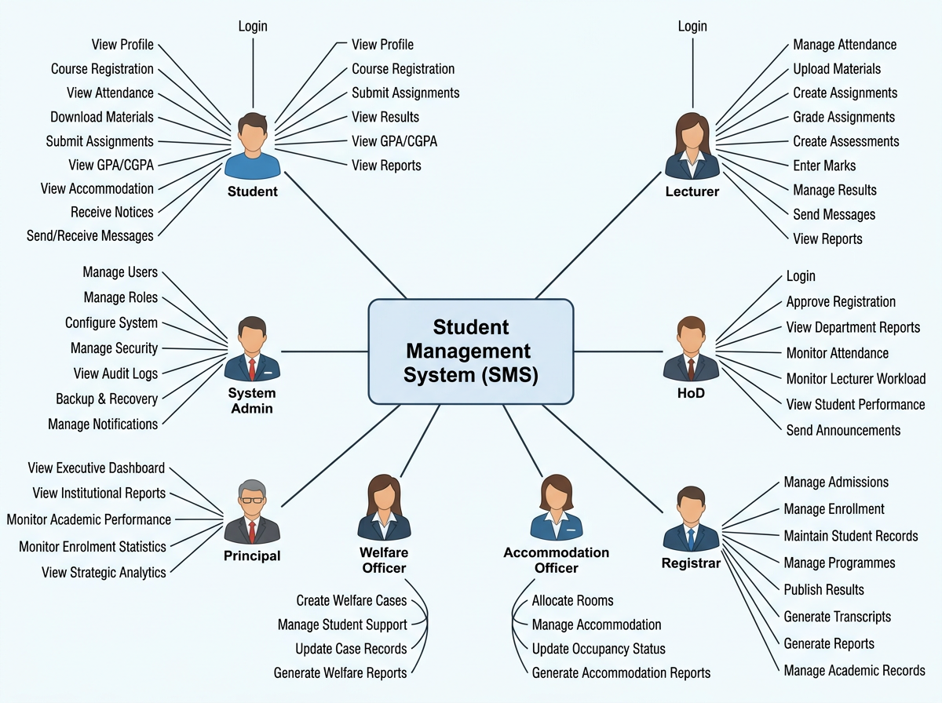

6.1 System Architecture

6.1.1 Description
The LCC-CMS is structured as a three-tier web application with an additional cloud infrastructure layer:
- Presentation Layer (Frontend): A React.js single-page application (SPA) providing a responsive, browser-based user interface accessible from any device connected to the college network or the internet. React's component-based architecture enables modular UI development aligned with the twelve system modules. The communication portal module uses Microsoft SignalR — a real-time WebSocket library for ASP.NET Core — to provide instant message delivery between staff and students without page reloads.
- Application Layer (Backend): An ASP.NET Core 8 Web API implementing RESTful API endpoints for all system operations. The backend enforces Role-Based Access Control (RBAC) through claims-based identity using tokens issued by Microsoft Entra ID via OAuth 2.0 / OIDC. Business logic — including GPA/CGPA calculation, enrolment validation, attendance rate computation, and report generation — is implemented in service classes within this layer. SignalR hubs manage real-time WebSocket connections for the messaging module.
- Data Layer (Database): Azure SQL Database (SQL Server 2022 engine) stores all persistent application data across 20 relational tables normalised to Third Normal Form (3NF). Azure Blob Storage provides scalable, durable file storage for learning materials, assignment submissions, and institutional documents. Both storage services are accessed exclusively through the application layer — clients never interact with the database or blob storage directly.
- Cloud Infrastructure Layer: Microsoft Azure hosts all system components — the React SPA is served via Azure App Service, the ASP.NET Core API runs on the same App Service plan, Azure SQL Database provides managed relational storage, Azure Blob Storage provides file storage, and Azure Monitor provides logging, alerting, and performance monitoring. Microsoft Entra ID provides identity management. Azure Backup Services provides automated daily database backups with 30-day retention.
Figure showing the Three-tier Architecture of the system.
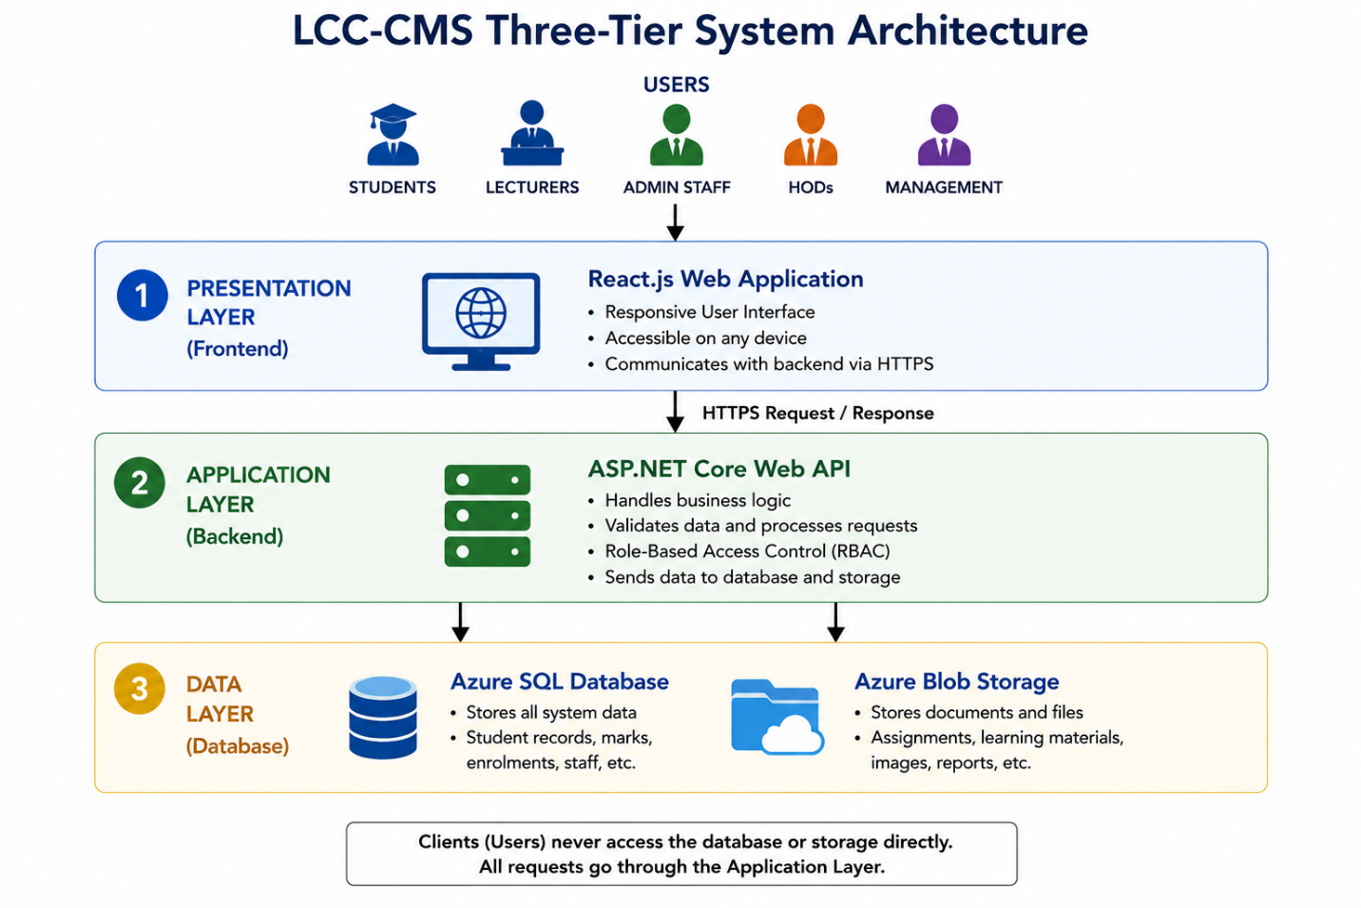

SYSTEM AUTHENTICATION
Figure below shows how the system will authenticate a user
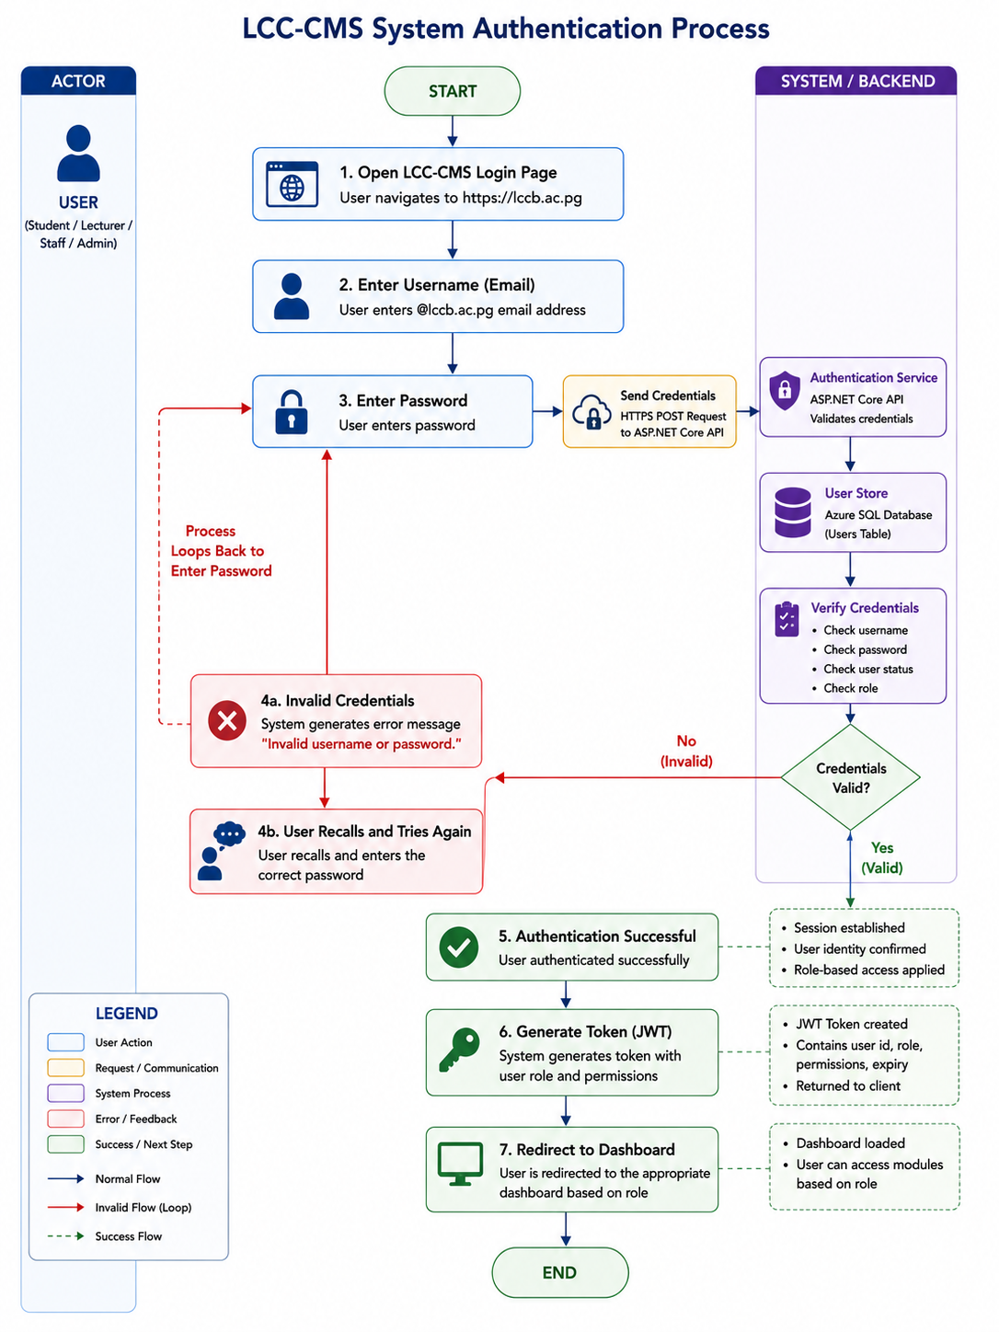

LCC-CMS — High-Level System Architecture on Microsoft Azure
USERS (Browser / React SPA) Student | Lecturer Admin | HoD | Mgmt | → | AZURE APP SERVICE (ASP.NET Core API) RBAC | Business Logic SignalR Hubs | → | AZURE SQL DB (SQL Server 2022) 20 Tables | 3NF All system data | → | AZURE BLOB STORAGE Documents Assignments Learning files | → | MICROSOFT ENTRA ID OAuth 2.0/OIDC SSO @lccb.ac.pg MFA | RBAC
↕ |  | ↕
SIGNALR (Real-time WS) Instant Messaging Staff ↔ Student | → | AZURE MONITOR Logs | Alerts Performance Diagnostics |  | AZURE BACKUP Daily DB backups 30-day retention Geo-redundant |  | lccb.ac.pg (NICTA DNS) Azure DNS Zone HTTPS / TLS 1.3

Figure 4: LCC-CMS High-Level System Architecture — Microsoft Azure Cloud Deployment

6.1.2 Network Design
The Lutheran Church College will use its own official website address: lccb.ac.pg. This is the official student/school domain for Papua New Guinea, managed by NICTA. Having this domain means the college has total control over its own website and doesn't have to rely on outside companies.
To set this up, we will use Azure DNS to direct anyone typing in lccb.ac.pg or www.lccb.ac.pg straight to the college's cloud system. We will also include a free security certificate (an SSL/TLS certificate). This protects the website and ensures that all information sent to and from it is safely encrypted. Finally, we will verify the website with Microsoft. This lets us create official school email accounts for all staff and students ending in @lccb.ac.pg.

Internet Access and Availability
Unlike older systems that only work inside the school building, this new cloud-based system (LCC-CMS) does not need any physical server equipment on campus to work.
As long as you have an internet connection and a web browser, you can log in from any device, anywhere. It will work using:
- The college's local Wi-Fi/network
- Mobile data (Digicel or Telikom PNG)
- Starlink satellite internet
This is a massive advantage for the college, as it ensures the system stays up and running even if the school's local power or internet goes down.
Figure below showsthe Lean-On on-premise network Design topology.
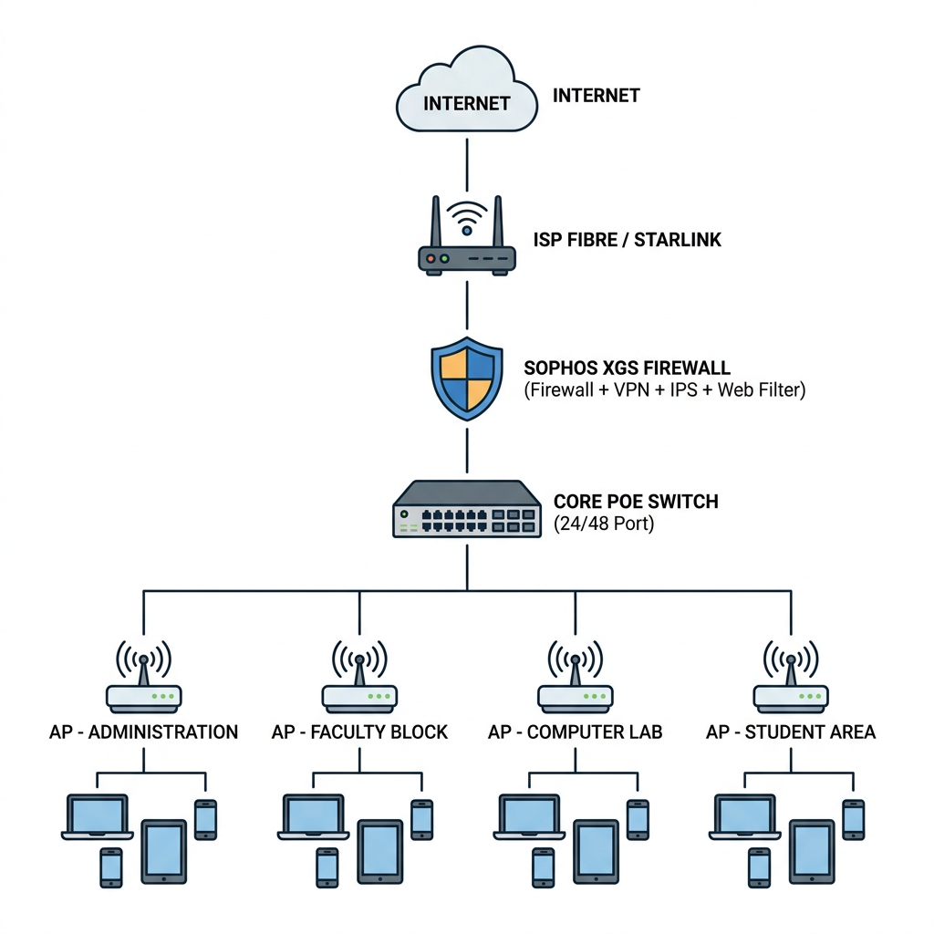

The cloud network security architecture is as follows:
Security Layer | Mechanism | Function
DNS / Domain | Azure DNS Zone + NICTA registration | Authoritative DNS for lccb.ac.pg; resolves to Azure App Service IP
Transport Security | HTTPS / TLS 1.3 (Azure Managed Cert) | Encrypts all data in transit between client browsers and Azure App Service
Application Firewall | Azure Web Application Firewall (WAF) | Protects against SQL injection, XSS, CSRF, and OWASP Top 10 vulnerabilities
Identity & Access | Microsoft Entra ID + RBAC | All API endpoints require a valid Entra ID token; role claims enforce module-level access
Multi-Factor Auth | Entra ID MFA (enforced for Admin roles) | Requires second factor (SMS or Authenticator app) for Admin, HoD, and Management roles
Data Encryption | Azure SQL TDE + Blob Storage SSE | All stored data encrypted at rest using AES-256 transparent data encryption
Audit Logging | Azure Monitor + custom audit_logs table | All data modifications logged with user identity, timestamp, and change details
Backup & Recovery | Azure Backup (daily, 30-day retention) | Automated daily database backups with point-in-time restore capability

Table 6: Cloud Network Security Architecture — LCC-CMS on Azure

6.1.3 Database Design
The LCC-CMS database is designed using the Relational Model, implemented in Azure SQL Database (SQL Server 2022 engine). The schema is normalised to Third Normal Form (3NF) to eliminate data redundancy and enforce referential integrity. An Enhanced Entity-Relationship (EER) diagram is used to model the generalisation relationship between the User supertype and the Student and Staff subtypes, reflecting the institutional hierarchy.
The database consists of 20 entities supporting all twelve system modules. The following table defines all entities, their key attributes, and their relationships:

Entity (Table) | Key Attributes | Primary Key | Key Relationships
users | id, entra_oid, name, email, role ENUM(5 roles), is_active, created_at | id (INT, AUTO) | 1:1→students; 1:1→staff; 1:M→notices; 1:M→messages(sender); 1:M→audit_logs
students | id, user_id, student_no, programme_id, year_level, enrolment_date, residential_status, status | id (INT, AUTO) | M:1→users; M:1→programmes; 1:M→registrations; 1:M→attendances; 1:M→welfare_cases; 1:1→accommodation_records
staff | id, user_id, staff_no, faculty_id, department_id, position, employment_type, join_date | id (INT, AUTO) | M:1→users; M:1→departments; 1:M→course_allocations
faculties | id, name, code, head_staff_id, description | id (INT, AUTO) | 1:M→departments; 1:M→staff
departments | id, faculty_id, name, code, hod_staff_id | id (INT, AUTO) | M:1→faculties; 1:M→programmes; 1:M→staff
programmes | id, department_id, name, code, duration_years, award_type, total_credit_points | id (INT, AUTO) | M:1→departments; 1:M→courses; 1:M→students
courses | id, programme_id, name, code, credit_points, semester, year_level, description | id (INT, AUTO) | M:1→programmes; 1:M→registrations; 1:M→attendances; 1:M→assessments
semesters | id, name, year, semester_no, start_date, end_date, is_current BOOL | id (INT, AUTO) | 1:M→registrations; 1:M→assessments; 1:M→attendance_sessions
course_allocations | id, course_id, staff_id, semester_id | id (INT, AUTO) | M:1→courses; M:1→staff; M:1→semesters. Lecturer–course assignment junction.
admissions | id, applicant_name, email, programme_id, application_date, status, processed_by_staff_id, enrolment_date | id (INT, AUTO) | M:1→programmes; M:1→staff (processor). On approval → creates student record.
registrations | id, student_id, course_id, semester_id, registration_date, status, approved_by_staff_id | id (INT, AUTO) | M:1→students; M:1→courses; M:1→semesters. Junction — student course enrolment per semester.
attendance_sessions | id, course_allocation_id, session_date, topic, semester_id | id (INT, AUTO) | M:1→course_allocations; 1:M→attendances
attendances | id, attendance_session_id, student_id, status ENUM('present','absent','late','excused'), remarks | id (INT, AUTO) | M:1→attendance_sessions; M:1→students
assignments | id, course_allocation_id, title, description, due_date, max_marks, file_path | id (INT, AUTO) | M:1→course_allocations; 1:M→submissions
submissions | id, assignment_id, student_id, submitted_at, file_path, marks_awarded, feedback, graded_by_staff_id | id (INT, AUTO) | M:1→assignments; M:1→students; M:1→staff
assessments | id, course_allocation_id, semester_id, assessment_type, max_marks, weight_percent, is_published BOOL | id (INT, AUTO) | M:1→course_allocations; 1:M→grades
grades | id, assessment_id, student_id, marks_awarded, grade_letter, gpa_points, entered_by_staff_id | id (INT, AUTO) | M:1→assessments; M:1→students. GPA auto-calculated from marks.
accommodation_records | id, student_id, hostel_name, room_no, allocated_date, vacated_date, status | id (INT, AUTO) | M:1→students. 1 active record per residential student.
welfare_cases | id, student_id, case_type, description, reported_date, status, assigned_staff_id, resolution_notes | id (INT, AUTO) | M:1→students; M:1→staff
notices | id, posted_by_user_id, title, body, target_role, is_pinned BOOL, published_at | id (INT, AUTO) | M:1→users
messages | id, sender_user_id, recipient_user_id, body, is_read BOOL, read_at, created_at, deleted_at | id (INT, AUTO) | M:1→users (sender); M:1→users (recipient). Staff↔Student only via RBAC.
audit_logs | id, user_id, action, table_name, record_id, old_value TEXT, new_value TEXT, ip_address, timestamp | id (INT, AUTO) | M:1→users. All create/update/delete operations logged.
Table 7: Database Entity Definitions — LCC-CMS Azure SQL Database (22 Tables)

An Enhanced Entity-Relationship (EER) diagram is used to model the generalization relationship between the User supertype and the Student and Staff subtypes, reflecting the institutional hierarchy will be illustrated in detail in the system documentation report.

6.2 Process Design
This section describes the six key business processes implemented in the LCC-CMS, supported by process flow diagrams. Full UML activity diagrams, use case diagrams, and system sequence diagrams will be included in the Final Project Report.

Process 1: Student Admission and Enrolment
Actors: Applicant (external); Registrar/Admin (internal). Precondition: A programme is available and open for applications. Postcondition: Student account created, Entra ID account provisioned, student can log in. Business rule: Admission approval triggers automatic student record and user account creation.

1. Applicant submits online application form | → | 2. Registrar reviews application | → | 3. Decision: Approve / Reject | → | 4. System creates Student + User records | → | 5. Entra ID account provisioned @lccb.ac.pg | → | 6. Student receives welcome email + login

Figure 6: Student Admission and Enrolment Process Flow

Process 2: Course Registration
Actors: Student (initiates); HoD or Registrar (approves). Precondition: Semester is active; student is enrolled in the programme; courses are available. Postcondition: Student is registered in selected courses for the semester. Business rule: A student may not register for a course they have already passed; maximum course load per semester enforced.

1. Student logs in & opens Registration | → | 2. Selects courses for current semester | → | 3. System validates prerequisites & load | → | 4. Registration submitted for approval | → | 5. HoD / Registrar approves or queries | → | 6. Student confirmed into courses

Figure 7: Course Registration Process Flow

Process 3: Assessment, Marks Entry, and Results Publication
Actors: Lecturer (marks entry); Admin/Registrar (results publication); Student (results view). Precondition: Assessment created; students registered in course. Postcondition: Published results visible on student dashboards; transcripts updated. Business rule: Marks must be between 0 and the assessment maximum. Post-publication edits require Admin override and are recorded in audit_logs with justification.

1. Lecturer creates assessment | → | 2. Enters marks per student (0–max) | → | 3. System auto-calculates grade & GPA points | → | 4. Registrar reviews marks for accuracy | → | 5. Admin publishes results | → | 6. Students view on dashboard

Figure 8: Assessment, Marks Entry, and Results Publication Process Flow

For example: Student GPA Calculation Process: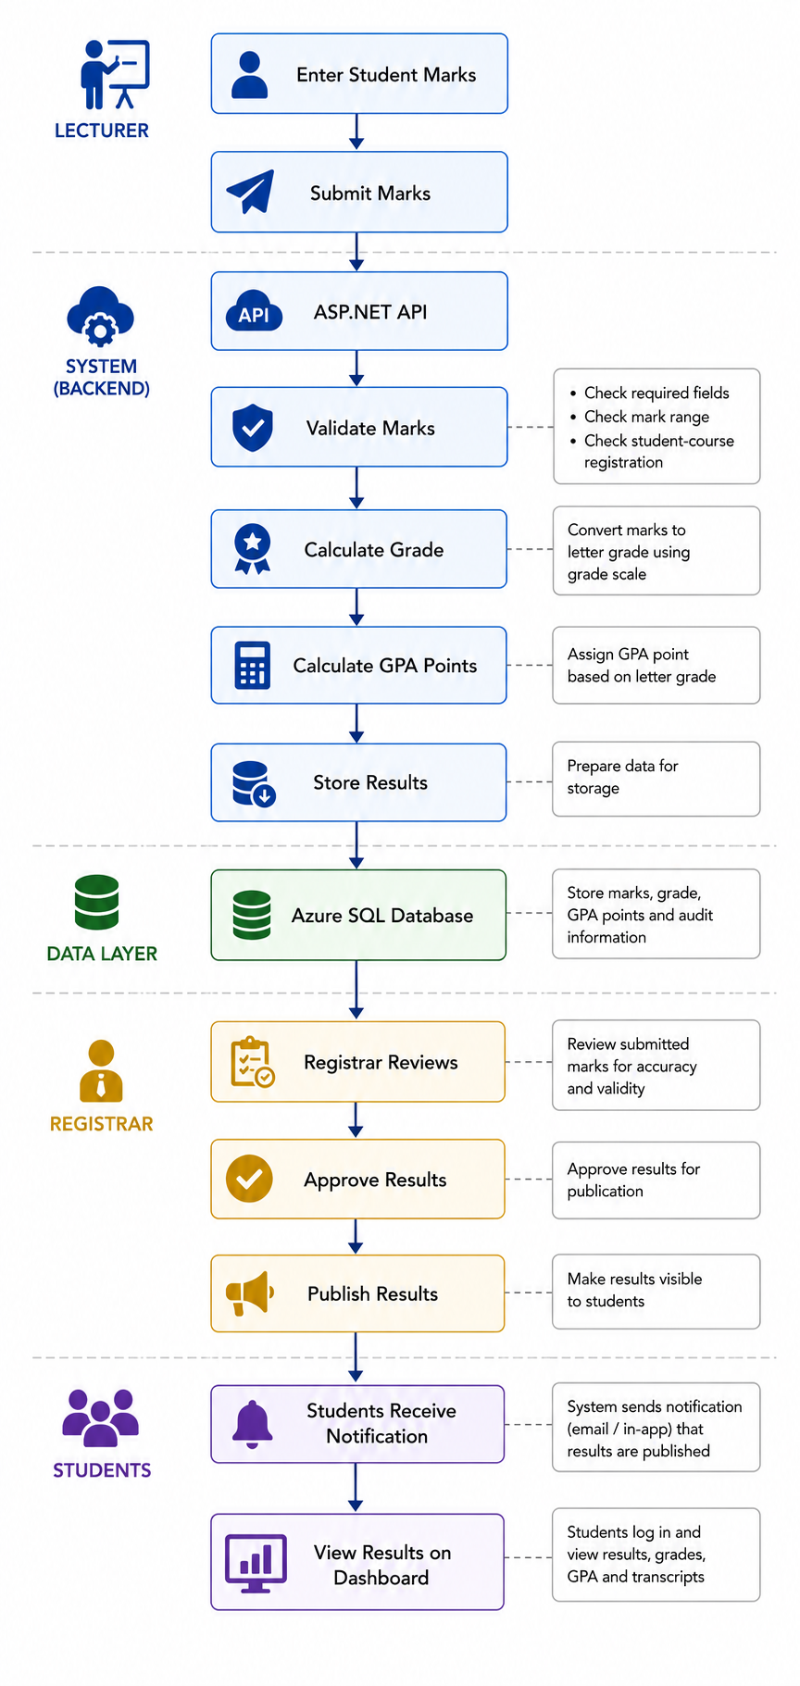

Mark Range (%) | Letter Grade | GPA Points | Classification
85 – 100 | HD | 4.0 | High Distinction
75 – 84 | D | 3.5 | Distinction
65 – 74 | C | 3.0 | Credit
50 – 64 | P | 2.0 | Pass
40 – 49 | F+ | 1.0 | Near Pass / Fail
0 – 39 | F | 0.0 | Fail

Table 8: GPA Grade Table — LCC Academic Standards

CGPA Calculation: The student's Cumulative GPA (CGPA) is calculated as the weighted average of GPA points across all completed courses, weighted by credit points: CGPA = Σ(GPA Points × Credit Points) ÷ Σ(Credit Points completed). This calculation is performed automatically by the system each time a new grade is recorded and is displayed on the student's academic dashboard and transcript.

Process 4: Attendance Recording and Monitoring
Actors: Lecturer (recording); HoD and Admin (monitoring). Precondition: Attendance session created for a class; students registered in the course. Postcondition: Attendance records saved; student attendance rate updated automatically. Business rule: Attendance rate below 75% triggers an alert to the student and their HoD.

1. Lecturer opens attendance for session | → | 2. Marks each student: present / absent / late | → | 3. System saves attendance records | → | 4. System calculates student attendance % | → | 5. Alert triggered if rate below 75% | → | 6. HoD / Admin view attendance reports

Figure 9: Attendance Recording and Monitoring Process Flow

Process 5: Staff-Student Instant Messaging (Communication Portal)
Actors: Staff (Lecturers, Admin, HoD, Management) and Students. Precondition: Both parties authenticated; at least one is a staff member — RBAC enforces staff-student only, preventing student-to-student messaging. Postcondition: Message delivered in real time via SignalR WebSocket; message persisted in database. Business rule: Messages may not be blank; deleted messages are soft-deleted and retained for audit.

1. User opens Messages module | → | 2. Selects recipient (staff selects student; student selects staff) | → | 3. Types message & sends | → | 4. API saves message to messages table | → | 5. SignalR hub pushes to recipient WebSocket connection | → | 6. Recipient sees message instantly in chat UI
Figure 10: Staff-Student Instant Messaging Process Flow — SignalR WebSocket

Process 6: Accommodation Allocation and Welfare Management
Actors: Admin/Registrar (accommodation); Student Welfare Officer/Admin (welfare cases). Precondition: Student has residential status; hostel rooms have available capacity. Postcondition: Room allocation recorded; student accommodation record created. For welfare: case logged, assigned to appropriate staff, and tracked through to resolution.

1. Student submits accommodation request | → | 2. Admin reviews room availability | → | 3. Room allocated & record created | → | 4. Student notified via portal | → | 5. Welfare case logged if required | → | 6. Case tracked to resolution by welfare staff

Figure 11: Accommodation Allocation and Welfare Management Process Flow

6.3 Future System Expansion
The LCC-CMS has been deliberately designed with a modular, cloud-native architecture that supports incremental expansion into a comprehensive institutional intranet platform over multiple phases. The following roadmap outlines the planned future expansion of the system beyond the scope of this project:

Phase | Title | Planned Capabilities
Phase 2 | Communication & Collaboration Services | Staff Portal with departmental dashboards; digital notice boards replacing physical boards; institutional policy and document management; internal team collaboration spaces; full integration with Microsoft Teams via Microsoft 365 for Education.
Phase 3 | Institutional Management Systems | Human Resource Management module (staff leave, payroll integration, performance management); Asset Management (tracking of college equipment and property); Inventory Management; Procurement Management with approval workflows.
Phase 4 | Advanced Digital Services | Student Finance Portal (fee management, payment tracking, scholarship management); Native mobile applications for iOS and Android; Business Intelligence dashboards with Power BI integration; AI-assisted student support chatbot; workflow automation using Azure Logic Apps; integration with Papua New Guinea national education data systems.
Long-term Vision | Fully Integrated Intranet Ecosystem | Transform Lutheran Church College into a fully digitised institution with a single-point-of-access intranet portal — one unified digital environment for all academic, administrative, communication, institutional, and student support services, accessible to all staff and students from any device, anywhere.

Table 9: Future System Expansion Roadmap — LCC Digital Transformation Phases

7. Conclusion
This proposal outlines a clear plan to build a cloud-based Student Management System (LCC-CMS) for Lutheran Church College (LCC) in Banz, Jiwaka Province. Currently, the college relies entirely on slow, disconnected paper processes. This new 12-module system is designed to fix all seven of the major day-to-day challenges the school faces.

A Modern, Cloud-First System
Instead of buying expensive physical servers that require a specialized IT team to maintain on campus, the new system will live entirely in the cloud using Microsoft Azure. It will be secure, reliable, and backed up automatically. Users will be able to log in safely using their official school email addresses (@lccb.ac.pg).

What the System Will Do
The 12 modules will completely digitize and centralize school operations, covering everything from student admissions and grades to staff management and campus housing. It also includes a built-in, real-time messaging system so teachers and students can instantly communicate with each other, closing a major communication gap at the college.

Built for the Future
The technical groundwork is already fully planned, featuring a secure database structure, clear process maps, and a realistic 10-week development schedule.
Most importantly, the LCC-CMS is not just a one-time software update—it is the foundation for the college’s long-term digital future. This project sets up the infrastructure, cloud systems, and student accounts needed to easily add more advanced digital features in the coming years, helping LCC provide modern, reliable services to its students, staff, and the wider Jiwaka community.

8. Glossary
Term / Acronym | Definition
3NF | Third Normal Form — a database normalisation standard that eliminates transitive dependencies to reduce data redundancy and improve integrity.
API | Application Programming Interface — a set of protocols enabling communication between software components.
ASP.NET Core | Microsoft's open-source, cross-platform web framework for building RESTful APIs and web applications.
Azure | Microsoft's cloud computing platform providing managed hosting, database, storage, identity, and monitoring services.
Azure App Service | A managed Platform-as-a-Service (PaaS) offering from Microsoft Azure for hosting web applications and APIs.
Azure Blob Storage | Microsoft Azure's scalable object storage service for unstructured data such as documents, images, and files.
Azure SQL Database | Microsoft Azure's managed relational database service based on the SQL Server engine.
CGPA | Cumulative Grade Point Average — the weighted average GPA across all semesters of a student's academic programme.
CI/CD | Continuous Integration / Continuous Deployment — automated software build, test, and deployment pipelines.
CRUD | Create, Read, Update, Delete — the four fundamental operations of a persistent database application.
EER | Enhanced Entity-Relationship Diagram — an extended ERD supporting generalisation/specialisation (supertypes and subtypes).
Entra ID | Microsoft's cloud-based identity and access management service (formerly Azure Active Directory).
ERD | Entity-Relationship Diagram — a visual model of database entities, attributes, and their relationships.
GPA | Grade Point Average — a numerical measure of a student's academic performance in a given semester.
HoD | Head of Department — a senior academic staff member responsible for managing a college department.
HTTPS | Hypertext Transfer Protocol Secure — HTTP with TLS encryption, ensuring secure data transmission.
MFA | Multi-Factor Authentication — requires a second verification factor in addition to a password for login.
NICTA | National Information and Communications Technology Authority — Papua New Guinea's ICT regulator and .ac.pg domain registrar.
OAuth 2.0 | An open authorisation framework enabling applications to access user resources without exposing credentials.
OIDC | OpenID Connect — an identity layer built on OAuth 2.0 used for user authentication and identity verification.
RBAC | Role-Based Access Control — assigns permissions to roles rather than individuals; users are assigned to roles.
React.js | A JavaScript library developed by Meta for building component-based, responsive single-page web applications.
SignalR | ASP.NET Core's library for real-time WebSocket communication between server and browser clients.
SIS / SMS | Student Information System / Student Management System — software managing student academic and administrative data.
SPA | Single-Page Application — a web application that dynamically rewrites the page without full browser reloads.
SSO | Single Sign-On — allows users to authenticate once and access all integrated services without re-entering credentials.
TLS | Transport Layer Security — the cryptographic protocol securing internet communications (successor to SSL).
UAT | User Acceptance Testing — end-user validation that the system meets operational requirements before go-live.
WAF | Web Application Firewall — protects web applications against common exploits such as SQL injection and XSS.
WebSocket | A communication protocol providing persistent, full-duplex, real-time communication between client and server.

9. References
- Beck, K., Beedle, M., van Bennekum, A., Cockburn, A., Cunningham, W., Fowler, M., Grenning, J., Highsmith, J., Hunt, A., Jeffries, R., Kern, J., Marick, B., Martin, R. C., Mellor, S., Schwaber, K., Sutherland, J., & Thomas, D. (2001). Manifesto for Agile Software Development. Agile Alliance. https://agilemanifesto.org
- Ferraiolo, D., & Kuhn, R. (1992). Role-based access controls. Proceedings of the 15th NIST-NCSC National Computer Security Conference, 554–563.
- Heeks, R. (2018). Information and communication technology for development (ICT4D). Routledge.
- Laudon, K. C., & Laudon, J. P. (2022). Management information systems: Managing the digital firm (17th ed.). Pearson.
- Microsoft. (2024a). Microsoft 365 Education. Microsoft Corporation. https://www.microsoft.com/en-us/education/products/office
- Microsoft. (2024b). Azure for education and research. Microsoft Corporation. https://azure.microsoft.com/en-us/solutions/industries/education
- Microsoft. (2024c). What is Microsoft Entra ID? Microsoft Learn. https://learn.microsoft.com/en-us/entra/fundamentals/whatis
- National Information and Communications Technology Authority [NICTA]. (2022). Papua New Guinea national ICT policy framework 2022–2027. Government of Papua New Guinea.
- Pressman, R. S., & Maxim, B. R. (2020). Software engineering: A practitioner's approach (9th ed.). McGraw-Hill.
- Sommerville, I. (2021). Software engineering (10th ed.). Pearson.
- Stair, R., & Reynolds, G. (2023). Principles of information systems (14th ed.). Cengage Learning.
- Turban, E., Pollard, C., & Wood, G. (2021). Information technology for management: On-demand strategies for performance, growth, and sustainability (12th ed.). Wiley.
- AI Tools Used:
Tool | Purpose
- Claud | Research & Documentation Assistance
- Napkin | Image Generation
- CoPilot | Research
- ChatGPT | Research & Diagram Generation
- Mango/Google | Research
- Gramarly | Spelling and Grammar

